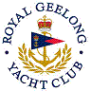 | Royal Geelong Yacht Club Inc.  Est 1859
Trophy Deed of Gift.

Trophy: | Bolle Trophy
Presented by: | Jean Van Hulsen
Date: | 2005
For: | Any achievement which promotes sailing as a sport of fun and personal or group development not driven by commercial interest or abnormal finance’
Remarks / Revisions
Click here for a List of Recipients

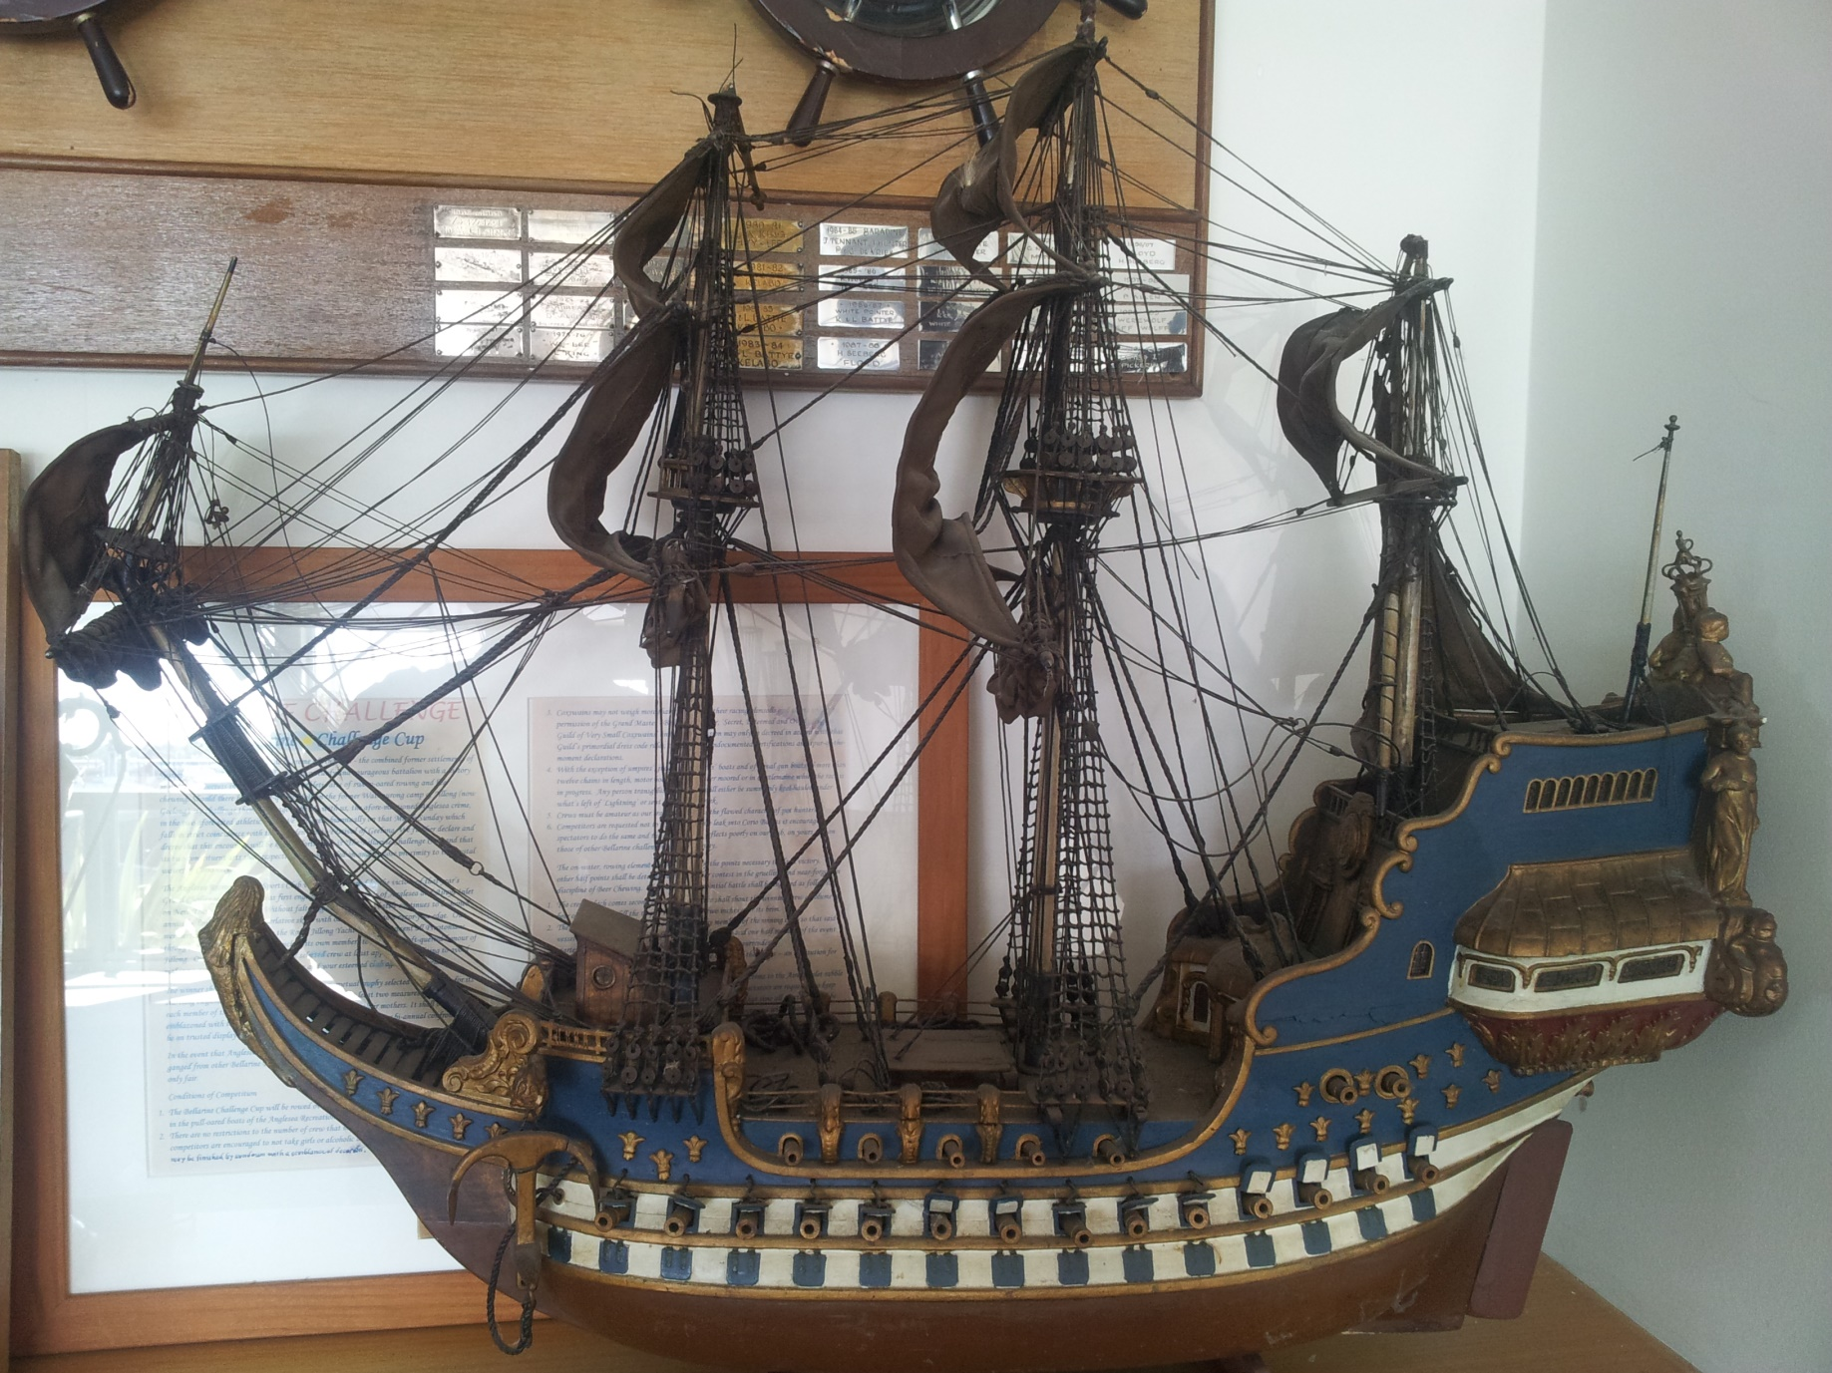

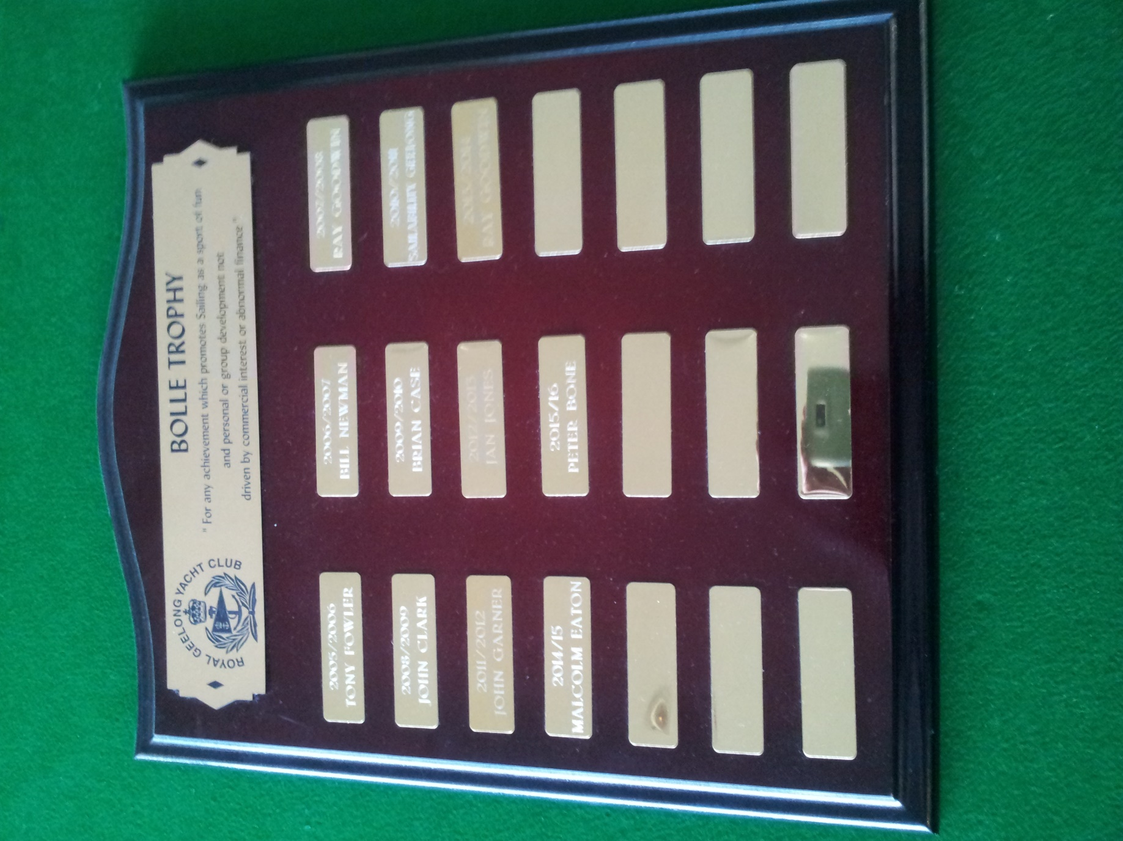
Bolle Trophy Replica

